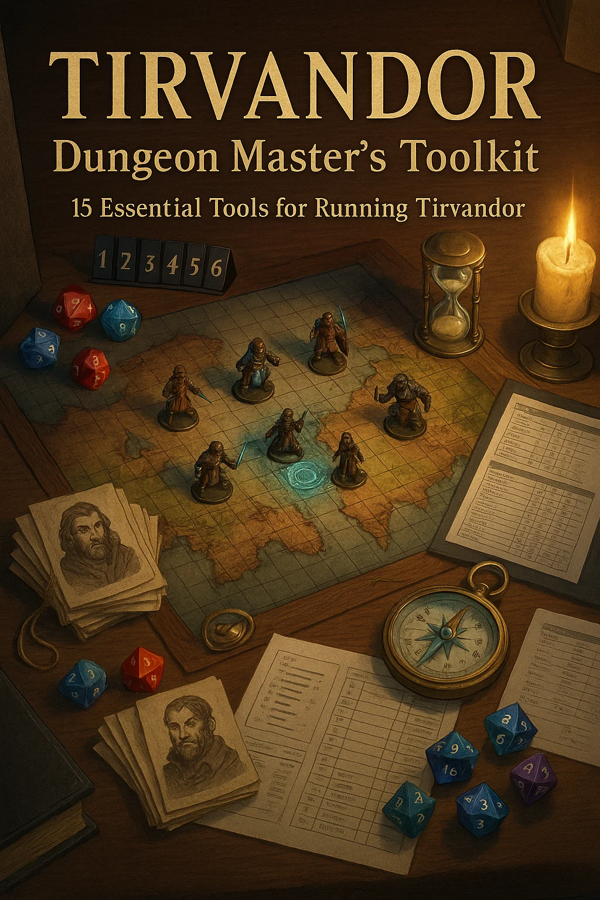

*© 2024-2025 Tirvandor Campaign Setting. All rights reserved.  
For personal tabletop use only. Not for commercial distribution.*

# NPC Quick Reference Cards

Essential NPCs for Tirvandor Campaigns - Top 20

## King Aldric Iv Thandris

|  |  |
| --- | --- |
|  | **Title:** High King of Thaldros  **Age:** 52 | **Race:** Human | **Location:** Kaer Thandros  **Personality:** Stern but fair military commander, no-nonsense warrior-king  **Voice/Mannerism:** Deep, commanding voice. Always stands with military posture. Scar on left cheek.  **What He Wants:**   * Reunification of the kingdoms * Strong borders against threats * Respect for military tradition   **What He Knows:**   * Complete military situation * Border threats and defenses * Political landscape of Thaldros   **Quick Stats:** Fighter 15 | AC 20 | HP 165 | Wields Thrandil's Edge (legendary longsword)  **Key Quote:** *"The mountain bows to no one—neither shall we."* |

## High Queen Aelindra Aethermere

|  |  |
| --- | --- |
|  | **Title:** High Queen of Aethoria Republic  **Age:** 487 (appears mid-30s) | **Race:** High Elf | **Location:** Aethermere  **Personality:** Wise, patient, otherworldly. Values knowledge over force.  **Voice/Mannerism:** Soft, melodic voice. Serene demeanor. Silver hair shimmers. Always calm.  **What She Wants:**   * Preservation of elven knowledge * Peace through wisdom, not war * Reunification when "the time is right"   **What She Knows:**   * Ancient history and prophecies * Magical secrets and divination * True nature of threats to the realm   **Quick Stats:** Wizard 16 (Divination) | AC 17 | HP 105 | Can see possible futures  **Key Quote:** *"The stars remember what mortals forget. We are their keepers."* |

## Sultan Rashid Al-Sahir

|  |  |
| --- | --- |
|  | **Title:** Sultan of Sundara, "The Twice-Blessed"  **Age:** 68 | **Race:** Human | **Location:** Sundara  **Personality:** Wise spiritual leader, grandfatherly, deeply compassionate  **Voice/Mannerism:** Warm, gentle voice. Moves gracefully despite age. White braided beard.  **What He Wants:**   * Peace and prosperity for his people * Balance between tradition and progress * Spiritual enlightenment for all   **What He Knows:**   * Desert secrets and ancient lore * Religious prophecies * Trade routes and desert survival   **Quick Stats:** Cleric 14 (Life) / Monk 2 | AC 18 | HP 126 | Master healer  **Key Quote:** *"The desert teaches patience. Water comes to those who wait, death to those who rush."* |

## Lord Commander Gareth Lightbane

|  |  |
| --- | --- |
|  | **Title:** Leader of the Iron Council  **Age:** 45 | **Race:** Human | **Location:** Mobile (Iron Council HQ)  **Personality:** Noble paladin, unwavering honor, inspirational leader  **Voice/Mannerism:** Firm but kind. Commands respect through presence. Perfect posture.  **What He Wants:**   * Protect the realm from darkness * Uphold oaths and honor * Unite factions against threats   **What He Knows:**   * Military tactics and strategy * Undead/demon threats * Secret alliance networks   **Quick Stats:** Paladin 15 | AC 20 | HP 142 | Oath of Devotion  **Key Quote:** *"Our oath is our bond. We stand between darkness and the innocent."* |

## Trade Prince Lucian Goldfingers

|  |  |
| --- | --- |
|  | **Title:** Leader of the Merchant League  **Age:** 58 | **Race:** Human | **Location:** Goldreach  **Personality:** Cunning merchant-prince, charming but ruthless in business  **Voice/Mannerism:** Smooth, persuasive voice. Always calculating. Wears excessive jewelry.  **What He Wants:**   * Expand trade routes and profits * Political influence through wealth * Monopoly on key goods   **What He Knows:**   * Economic secrets and market manipulation * Trade route vulnerabilities * Blackmail material on rivals   **Quick Stats:** Rogue 12 (Mastermind) | AC 16 | HP 96 | Master of negotiation  **Key Quote:** *"Everything has a price, my friend. Even principles."* |

## Master Crimson

|  |  |
| --- | --- |
|  | **Title:** Shadowy Leader of The Syndicate  **Age:** Unknown | **Race:** Unknown (wears red mask) | **Location:** Unknown  **Personality:** Mysterious, calculating, operates through fear and manipulation  **Voice/Mannerism:** Distorted voice through mask. Never shows face. Red mask is signature.  **What He Wants:**   * Control the criminal underworld * Remain hidden and untouchable * Undermine legitimate authority   **What He Knows:**   * Everyone's secrets * Location of hidden treasures * Weaknesses of powerful figures   **Quick Stats:** Rogue 16 (Assassin) | AC 18 | HP 112 | Master of disguise and poison  **Key Quote:** *"You can't fight what you can't see. And you'll never see me coming."* |

## Grand Warden Volcanus Rex

|  |  |
| --- | --- |
|  | **Title:** Leader of the Ashwardens  **Age:** 67 | **Race:** Fire Genasi | **Location:** Ashmar Fortress  **Personality:** Gruff but dedicated, lives for duty, obsessed with preventing eruptions  **Voice/Mannerism:** Gravelly voice. Skin flickers with fire. Intense, burning eyes.  **What He Wants:**   * Prevent catastrophic eruptions * Maintain the Ashen Seal * Protect innocent lives   **What He Knows:**   * Volcanic science and magic * Elemental plane connections * Ancient fire rituals   **Quick Stats:** Sorcerer 14 (Wild Magic) / Fighter 2 | AC 16 | HP 122 | Fire immunity  **Key Quote:** *"We hold back the inferno. If we fail, the world burns."* |

## Council Speaker Aquila Clearwater

|  |  |
| --- | --- |
|  | **Title:** Speaker of the Aethorian Council  **Age:** 523 (appears 40) | **Race:** High Elf | **Location:** Aethermere  **Personality:** Pragmatic diplomat, balances idealism with reality  **Voice/Mannerism:** Clear, eloquent speech. Measured words. Natural authority.  **What She Wants:**   * Effective governance of Aethoria * Balance between tradition and progress * Peace through diplomacy   **What She Knows:**   * Political maneuvering and alliances * Council secrets and power structure * Elven history and precedent   **Quick Stats:** Bard 12 (Eloquence) | AC 15 | HP 84 | Master diplomat  **Key Quote:** *"Words are the foundation of civilization. Choose them wisely."* |

## Warden Commander Thalia Moonbow

|  |  |
| --- | --- |
|  | **Title:** Leader of the Ironspine Rangers  **Age:** 214 (appears 30) | **Race:** Wood Elf | **Location:** Ironspine Mountains  **Personality:** Fierce protector of wilderness, distrusts civilization  **Voice/Mannerism:** Quiet voice. Moves like a ghost. Always has bow ready.  **What She Wants:**   * Preserve the wild places * Stop despoiling of nature * Maintain balance between civilization and wild   **What She Knows:**   * Secret paths through wilderness * Monster lairs and threats * Ancient druidic sites   **Quick Stats:** Ranger 14 (Hunter) | AC 18 | HP 112 | Expert tracker and archer  **Key Quote:** *"The forest keeps its own counsel. We merely listen and protect."* |

## Forge-Master Rurik Ironanvil

|  |  |
| --- | --- |
|  | **Title:** Master of the Forgebound Guild  **Age:** 287 | **Race:** Mountain Dwarf | **Location:** Ironhold  **Personality:** Perfectionist craftsman, gruff exterior but kind heart  **Voice/Mannerism:** Booming voice. Smells of forge smoke. Constantly examining craftsmanship.  **What He Wants:**   * Create perfect masterwork items * Preserve ancient smithing techniques * Train worthy apprentices   **What He Knows:**   * Legendary item creation * Location of rare metals * Ancient forging secrets   **Quick Stats:** Artificer 12 | AC 17 | HP 98 | Can identify any item  **Key Quote:** *"A blade ain't just metal. It's a promise. And I keep my promises."* |

## Archdruid Silvaris Oakenheart

|  |  |
| --- | --- |
|  | **Title:** Leader of the Druidic Circle  **Age:** 654 (appears 50) | **Race:** Wood Elf | **Location:** Sacred Grove  **Personality:** Ancient wisdom, connected to nature's rhythms, patient but firm  **Voice/Mannerism:** Deep, resonant voice. Speaks slowly. Birds and animals gather nearby.  **What He Wants:**   * Prevent corruption of nature * Maintain the natural balance * Protect sacred groves   **What He Knows:**   * Natural disasters and omens * Secret druid lore * Beast languages and ancient trees   **Quick Stats:** Druid 16 (Circle of the Land) | AC 16 | HP 128 | Can wildshape into CR 5 beasts  **Key Quote:** *"The trees have memories. Listen, and they will teach you."* |

## Prince Aldric Thandris

|  |  |
| --- | --- |
|  | **Title:** Crown Prince, Heir to Thaldros  **Age:** 28 | **Race:** Human | **Location:** Kaer Thandros  **Personality:** Idealistic young warrior, wants to prove himself, slightly reckless  **Voice/Mannerism:** Energetic, passionate speech. Eager to please father. Impulsive.  **What He Wants:**   * Prove worthy of the crown * Earn father's respect * Make a name beyond "the King's son"   **What He Knows:**   * Military training (less experienced) * Court politics and nobles * Secret desire for adventure   **Quick Stats:** Fighter 8 / Paladin 2 | AC 19 | HP 82 | Oath of Glory  **Key Quote:** *"I will not hide behind my father's shadow. I will forge my own legend!"* |

## Princess Elanil Aethermere

|  |  |
| --- | --- |
|  | **Title:** Princess of Aethoria, Daughter of High Queen  **Age:** 187 (appears 25) | **Race:** High Elf | **Location:** Aethermere  **Personality:** Curious scholar, diplomatic like mother but more adventurous  **Voice/Mannerism:** Melodic voice. Constantly reading. Asks many questions.  **What She Wants:**   * Experience the world beyond palace * Learn practical magic, not just theory * Unite the kingdoms (secretly)   **What She Knows:**   * Arcane theory and history * Secret passages in Aethermere * Her mother's visions (partial)   **Quick Stats:** Wizard 10 (Abjuration) | AC 15 | HP 65 | Scholar and protector  **Key Quote:** *"Knowledge without experience is just words on a page. I want to write my own story."* |

## Merchant Prince Davos Goldshore

|  |  |
| --- | --- |
|  | **Title:** Merchant Prince (VILLAIN - Blood & Coin Campaign)  **Age:** 52 | **Race:** Human | **Location:** Goldreach  **Personality:** Charming publicly, ruthless privately. Master manipulator.  **Voice/Mannerism:** Smooth, trustworthy voice (deceptive). Warm smile hides cold eyes.  **What He Wants:**   * Monopolize all trade * Become wealthier than kings * Destroy rivals through any means   **What He Knows:**   * Criminal networks and assassins * Blackmail on nearly everyone * Hidden smuggling routes   **Quick Stats:** Rogue 14 (Mastermind) | AC 17 | HP 98 | Extremely dangerous  **Key Quote:** *"Business is war by other means. And I always win."*  **⚠️ DM NOTE:** Primary antagonist in Blood & Coin campaign! |

## Archmage Veridian Starweaver

|  |  |
| --- | --- |
|  | **Title:** Archmage of the Starlight Academy  **Age:** 421 (appears 45) | **Race:** High Elf | **Location:** Aethermere  **Personality:** Brilliant but absent-minded, obsessed with magical research  **Voice/Mannerism:** Speaks quickly. Often distracted. Arcane symbols float around him.  **What He Wants:**   * Unlock new schools of magic * Train the next generation * Prevent magical catastrophes   **What He Knows:**   * Rare and forbidden spells * Planar connections * Location of magical artifacts   **Quick Stats:** Wizard 16 (Evocation) | AC 17 | HP 112 | Master of destructive magic  **Key Quote:** *"Magic is the language of reality. I merely speak it fluently."* |

## Lord Commander Thrain Ironoak

|  |  |
| --- | --- |
|  | **Title:** Lord Commander of Thaldros Forces  **Age:** 198 | **Race:** Dwarf | **Location:** Kaer Thandros  **Personality:** Gruff veteran soldier, honorable, hates cowardice  **Voice/Mannerism:** Gravel voice. Missing an eye. Tells war stories. Refused magical healing for scars.  **What He Wants:**   * Protect Thaldros borders * Train competent soldiers * Earn his scars honorably   **What He Knows:**   * Complete military history * Border vulnerabilities * Secret dwarf strongholds   **Quick Stats:** Fighter 14 / Barbarian 2 | AC 19 | HP 156 | Veteran warrior  **Key Quote:** *"Good dwarves earn their scars. I've earned plenty."* |

## Lady Shadowleaf (Niriel)

|  |  |
| --- | --- |
|  | **Title:** Spymaster of Aethoria  **Age:** 312 (appears 35) | **Race:** Wood Elf | **Location:** Varies (in shadows)  **Personality:** Mysterious, pragmatic, does "necessary" dark deeds for greater good  **Voice/Mannerism:** Whisper-quiet voice. Appears from shadows. Never makes sound.  **What She Wants:**   * Protect Aethoria by any means * Eliminate threats before they manifest * Serve the High Queen loyally   **What She Knows:**   * Every secret in the realm * Assassination techniques * Hidden passages everywhere   **Quick Stats:** Rogue 14 (Assassin) / Ranger 2 | AC 18 | HP 108 | Shadow master  **Key Quote:** *"Secrets are currency. And I am very, very rich."* |

## The Scarlet Knife (Verena Shadowblade)

|  |  |
| --- | --- |
| [Portrait: tirvandor-npc-scarlet-knife-verena-shadowblade.png] | **Title:** Master Assassin of The Syndicate  **Age:** 34 | **Race:** Half-Elf | **Location:** Unknown  **Personality:** Cold professional, no unnecessary kills, has a code of honor  **Voice/Mannerism:** Icy, emotionless voice. Wears red and black. Twin daggers.  **What She Wants:**   * Perfect the art of assassination * Serve Master Crimson * Find worthy opponents   **What She Knows:**   * Every major political figure's routines * Poison formulas * How to disappear completely   **Quick Stats:** Rogue 13 (Assassin) | AC 17 | HP 91 | Death Strike expert  **Key Quote:** *"Nothing personal. It's just business."* |

## Master Smith Durgan Forgefire

|  |  |
| --- | --- |
|  | **Title:** Legendary Dwarven Smith  **Age:** 312 | **Race:** Mountain Dwarf | **Location:** Ironhold  **Personality:** Perfectionist, grumpy but fair, loves his craft above all  **Voice/Mannerism:** Gruff, dismissive of poor work. Braided beard. Covered in soot.  **What He Wants:**   * Create a legendary masterwork * Preserve ancient smithing arts * Find metal from fallen star   **What He Knows:**   * How to forge magical weapons * Location of mythril veins * Secret of adamantine   **Quick Stats:** Fighter 6 / Artificer 8 | AC 17 | HP 98 | Smithing prodigy  **Key Quote:** *"Steel don't lie. Either it's good or it ain't. This ain't."* |

## Council Mistress Elara Silverleaf

|  |  |
| --- | --- |
|  | **Title:** Aethorian Council Member, House Silverleaf Matriarch  **Age:** 456 (appears 40) | **Race:** High Elf | **Location:** Aethermere  **Personality:** Political strategist, values elven tradition, pragmatic  **Voice/Mannerism:** Formal, precise speech. Commands attention. Silver jewelry.  **What She Wants:**   * Preserve elven culture and power * Advance House Silverleaf interests * Balance tradition with necessity   **What She Knows:**   * Political leverage and alliances * Noble house secrets * Council voting patterns   **Quick Stats:** Bard 11 (Eloquence) / Wizard 3 | AC 14 | HP 78 | Master manipulator  **Key Quote:** *"The council decides the fate of nations. We do not take that lightly."* |

## QUICK NPC INDEX

|  |  |
| --- | --- |
|  | **Rulers:** Cards 1-3 (Aldric IV, Aelindra, Rashid)  **Faction Leaders:** Cards 4-11 (Gareth through Silvaris)  **Royal Heirs:** Cards 12-13 (Prince Aldric, Princess Elanil)  **Villains:** Card 14 (Davos Goldshore)  **Specialists:** Cards 15-20 (Archmage, military, rogues, craftsmen)  1. Print this document  2. Cut along card boundaries  3. Laminate for durability (optional but recommended)  4. Keep in DM binder for quick NPC reference  5. Match portrait files to cards for visual aid  **These 20 NPCs cover 80% of your important NPC interactions!** 🎭✨ |